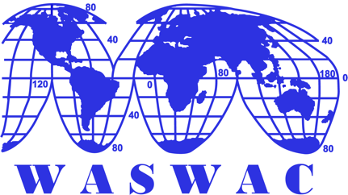

Announcement of

WASWAC Youth Outstanding Paper Award (DATUM) 2021
To encourage early-career scientists to contribute to soil and water conservation in the world, the WASWAC has held the WASWAC Youth Outstanding Paper Award three times since 2015. The fourth award in 2021 will be presented at the Third International Youth Forum on Soil and Water Conservation (IYFSWC), which will be held from May 16 to 21, 2021 in Iran (Noor City on Caspian Sea Shore). The application for the award is open from now.
This award will be presented to early-career scientists with outstanding research papers on soil and water conservation. The award consists of a Certificate from the WASWAC and a $1000 (USD) honorarium. In the case of multi-author papers, the award will be presented only to the first author. The WASWAC Youth Outstanding Paper Award (DATUM) 2021 is financially supported by the Beijing Datum Technology Company.

Eligibility
- The first author of the manuscript should be in their early career in research. In principle, preference will be given to scientists who are not beyond 40 years old (born after Jan 1, 1980).
- The papers should have creativity and originality, as reflected in new insights, interpretations, facts, innovations, methods, or applications.
- The papers should be written in English and should be clear, concise, comprehensible, and jargon-free, such that the papers are easy to read and understand.
- The papers submitted for consideration for the award should not have been previously published, and the authors should submit the paper with an oral presentation at the third International Youth Forum on Soil and Water Conservation (IYFSWC)
- The award papers must be submitted to the International Soil and Water Conservation Research (ISWCR) which is the official journal of WASWAC and SCIE indexed (IF 3.770) (http://www.keaipublishing.com/en/journals/international-soil-and-water-conservation-research/). The final publishing will go through peer reviewing follow the journal publishing procedures and rules.
- The previous awardees in 2015, 2016, and 2018 are ineligible for the award in 2021.

Procedure
- Application: The author should submit the abstract along with the application form duly completed by November 30, 2020. The full paper must be submitted by December 31, 2020.
- Peer-review and Nomination and process: The Award Committee will screen the application and form an expert panel for paper evaluation. Each paper will be evaluated and scored by at least three experts, the averaged score will be ranked for the final nomination.
- Evaluation and selection: Based on the nomination, the Award Committee will determine the final list to present the award.

Significant Dates:

Submission of application form with the abstract: November 30, 2020
Submission of Full paper: December 31, 2020
Nomination announcement: March 30, 2021
Final awardees announcement: May 2021
Application procedure:
Send your application form, abstract/full paper to the application directly to:
waswac-yopa@foxmail.com
All applications and full papers will be managed by the Award Secretary in Iran.
For more information please visit
http://iyfswc.modares.ac.ir/
or http://www.waswac.org/

Contacts:

Dr. Paige Chyu, iswcr@foxmail.com

Dr. Abdulvahed Khaledi Darvishan, vahedkhaledi@yahoo.com

Appendix: WASWAC Youth Outstanding Paper Award Application form

Appendix
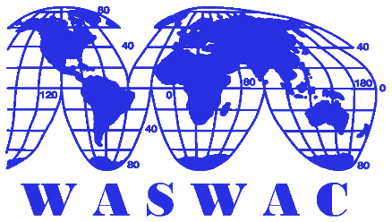 | World Association of Soil and Water Conservation  The Secretariat of WASWAC  No. 20 Chegongzhuang Road West, Beijing 100048, P. R. China  Tel: +86-10-68786579  Fax: +86-10-68411174  Email: waswac@foxmail.com waswac@163.com  Website: www.waswac.org
WASWAC Youth Outstanding Paper Award (DATUM) 2021
Application Form

Name (First, Last) |  |  | Gender
Date of birth |  | Professional field
Nationality
Work affiliation
Email address
Post address
Title of paper/presentation

Please prepare your full paper according to the guide for the author of the International Soil and Water Conservation Research
International Soil and Water Conservation Research
Guide for Authors
http://www.keaipublishing.com/en/journals/international-soil-and-water-conservation-research/

